This source code is licensed, not sold, and is subject to a written license agreement. Among other things, no portion of this source code may be copied, transmitted, disclosed, displayed, distributed, translated, used as the basis for a derivative work, or used, in whole or in part, for any program or purpose other than its intended use in compliance with the license agreement as part of the QualNet software. This source code and certain of the algorithms contained within it are confidential trade secrets of Scalable Network Technologies, Inc. and may not be used as the basis for any other software, hardware, product or service.

SCENARIO PURPOSE: Illustrate implementing Layer 3 Switch Ports in QualNet and EXata

SCENARIO:

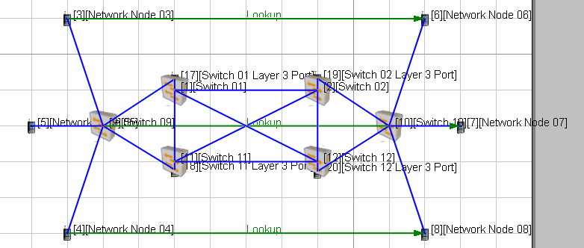

There are four Ethernet Switches that form a fully meshed wired network backbone. Each switch has a default device acting as a layer 3 switch port linked with a 1000 Gbps to the switch. The default device facilitates assigning a subnet IP address to the network spooked from the switch as EXata / QualNet Ethernet Switches do not support layer 3 switching definitions. Six nodes are paired using lookup for two way data exchange, RIP is the routing protocol.

APPLICATIONS:

LOOKUP, nodes 3 & 6, 5 & 7, 4 & 8

DESCRIPTION OF THE FILES:-

1. layer3switchPorts.app - QualNet configuration file for application input.
2. layer3switchPorts.config - QualNet configuration input file.
3. layer3switchPorts.expected.stat - QualNet statistics collection.
4. layer3switchPorts.nodes - QualNet configuration file for node position.
5. layer3switchPorts README.docx – This File source
6. layer3switchPorts README.pdf – This file Distributable